Environmental policy instruments project funded by EC

Project Objective

The overall objective of this project has been to “promote sustainable use of natural resources in order to reduce/prevent pollution”; with a specific objective “to increase the efficiency of the policy instruments for environmental protection, by assisting the Beneficiary and selected provincial and municipal Territorial Administrations for Environmental Protection in the development, implementation and enforcement of coherent mixes of policy instruments (‘policy packages’), with an emphasis on efficient inter-sectoral cooperation and integrated environmental management.”

Policy Packages

An early key activity was to engage with stakeholders to select three key environmental areas for project action: air quality management (AQM), river basin management (RBM) and municipal solids wastes management (MSWM). All areas had been relatively neglected to date, and all affect people directly or indirectly.

Policy packages were prepared as part of an extended process – see opposite - following a comprehensive assessment of the existing policy framework in Kazakhstan and with much stakeholder and national experts’ engagement. The assessment identified a number of key weaknesses in the policy framework, many of them generic including:

- Imprecise or unrealistic environmental goals
- Environmental monitoring infrastructures that have become degraded and not modernised to reflect current good practice
- Localised rather than systematic, regional or national analysis of environmental issues
- Environmental planning undertaken at local levels rather than strategically at regional or national level
- Immature or uncertain mechanisms for funding environmental investments
- Regulations that conflict with others or are ambiguous
- Environmental charges whose structures and levels often do not act as economic instruments to encourage positive changes in behaviour or recover costs

Analysis formed the basis for the preparation of 1st stage policy packages and pilot projects designs (PPM-1). The policy packages proposed in PPM-1 form coherent frameworks that directly address the major problems identified in previous analysis.

PPM-1 was reviewed in meetings of inter-sectoral Working Group chaired by the Ministry of Environmental Protection. Feedback from the Working Group and pilot projects were incorporated in the 2nd stage policy packages (PPM-2). PPM-2 represents a “hard core” of policy instruments and enabling measures.

Capacity Building

Objective Result

The beneficiary institutions will have improved knowledge and skills in planning, introduction and enforcement of effective environmental policy instruments.

Major Outputs

- Stakeholder roundtable meeting – to select three key environmental areas for project action (April 2009)

- National workshop on the evaluation of existing policy instruments, Astana September 2009 - the foundation on which policy packages have been built

- Inter-sectoral Working Group established under Ministry of Environmental Protection - met five times to review policy packages in the three selected environmental areas

- Study tour to Netherlands to learn from EU experience - especially influential regarding air quality management and economic instruments

- National workshops on policy packages and their introduction to pilot projects (Dec 2009) and the results of pilot projects (Jul 2010)

- Training and seminar events on good operation practice for waste landfill sites; BAT for reducing air pollution from industry; river basin management principles and practice - Lake Balkhash, Aral Sea; waste management tariffs; economic instruments

- Dissemination Conference in September 2010

- Page on website of Ministry of Environmental Protection holds all project technical reports, selected presentations and a selection of translated EU Directives
www.eco.gov.kz/rus_txt/ecopolicy.php
www.eco.gov.kz/eng/eng_txt/ecopolicy_eng.php

Air Quality Management (AQM) Policy Package

First Stage (PPM-1)

Air Quality PPM-1 comprised 21 policy instruments (regulatory, economic, information based). Some examples:

Regulatory Instruments
- Include range of health-based air quality indicators and develop the air quality monitoring systems
- Conduct assessment of air quality at specified (mostly polluted) urban areas to make more precise identification of the basic air polluting sources and planning the improvement measures

Economic Instruments
- Strengthen the financial penalties for stationery sources of emissions that are non-compliant with ELVs
- Increase significantly the fines for air pollution

Information based Instruments
- Establish a specialized unit in the MoEP responsible for emission standardization
- Develop and implement information programmes targeted at energy using sectors

Pilot project design

Almaty Air Quality Management pilot project was undertaken over the 5-month period of February to June 2010. This pilot project focused on air pollution resulting from road traffic emissions.

Here are the main policy instruments and measures assessed in this pilot project:

- Vehicle emissions - inspection regime / capacity and emissions inventory
- Air quality indicators, monitoring systems and public information
- Transport fuel quality
- New vehicle emission standards (EURO system)
- Transport planning and control

Second Stage (PPM-2)

Include fine particulate material and ozone as health-related indicators of air quality
These indicators of poor air quality are missing currently from the suite of air quality indicators adopted.

Upgrade air quality monitoring systems and information dissemination to public
Air quality monitoring information is relayed to the public with a month's delay at best whereas international best practice is to provide such information on an hourly basis.

Clarify and rationalise the standards applied to control the emission of air pollutants from industrial sources
The proposal is for emission limit values to be set for industrial sites, to be achieved over a period of time through the application of best available techniques.

Commit to adopt stricter quality standards for transport fuels
It is understood that the refineries are being upgraded to meet such requirements. The need for government commitment to cleaner fuels and a healthy, robust fuel quality inspection regime is emphasised.

Commit to adopt stricter emission standards for road vehicles
Higher Euro standards for imported vehicles are programmed in the years ahead. There is a need for a competent vehicle inspection system.

Prepare emission inventories using internationally accepted methodologies
Such inventories are valuable aids to help monitor the overall effectiveness of air quality management policies and to help determine the direction of future policies.

Strengthen economic instruments - transport fuel emission taxes and excise duties There is significant potential to increase the rates charged – whether to raise government revenue, change driving/purchasing behaviour so as to use fuel more efficiently, or use public transport or both.

Air Quality Management Pilot Project

Present Situation

Road transport is believed to be the main source of air pollution at ground level – believed responsible for 90 % of total emissions. Vehicle numbers in the city have grown significantly. Fuel quality is generally regarded as inconsistent at best and relatively high in sulphur content. The vehicle inspection system in Almaty (and elsewhere in Kazakhstan) is understood to be largely dysfunctional. Problems related to vehicle maintenance and methods of driving are not discussed and are practically unrecognized by society. Pollutants harmful to human health are not listed as mandatory air quality indicators and are not subject to continuous monitoring. Almaty Akimat’s freedom to act is constrained under state-level legislation.

Vehicle Numbers and Conditions

The chart on the right presents one of the salient points regarding road traffic and vehicles in Almaty City. Based on data from Kazakhstan Statistical agency and Almaty Road Traffic Police, the chart indicates the explosive growth in vehicle numbers in recent years, in particular since 2005. Mostly cars, vehicle numbers increased from about 90 000 in 1991 to about 200 000 in 2004 but then rocketed to about 500 000 in 2007-09 due mostly to large-engined cars. Previous studies have revealed that many vehicles that pass official tests are not compliant with environmental performance standards.

Almaty AQM Action Plan – Transport: Proposed Measures

An AQM action plan was prepared with twelve measures. The plan appreciates the dividing line that exists between the functions and actions that the City Akimat has the authority to undertake independently of state-level government, and those for which state-level authority is required. Hence the plan proposes two main groups of measures – guided substantially by the “Clean Driving” concept – see opposite. This provides a strategic basis for most of the measures, starting at a basic level with effective vehicle maintenance, inspection and driver behaviour; progressing upwards through improved fuel quality etc. Local actions proposed included:
- Strengthening the vehicle inspection system – institutional arrangements agreed in principle with the environmental department of Alamty Akimat are proposed. Building capacity through using project-specified and EU-procured equipment for the dynamic testing of diesel-engined buses - a working group to manage its use was elaborated
- Real-time monitoring of vehicle emissions and developing an emissions inventory ()
- Strengthening the liquid fuels inspection and control system
- Transport planning involving the use of roadside sensors to monitor vehicle emissions and control vehicle access to the city.

Proposed measures requiring national level sanction included:
- Extending Almaty Akimat’s freedom of action regarding environmental protection
- Extending the system of air quality indicators to include PMs and ozone and upgrading the monitoring systems and information dissemination to the public
- Improvements to fuel quality and accelerating the introduction of higher Euro standards regarding vehicle emissions
- Using economic instruments e.g. vehicle taxes and excise duties.

Municipal Solid Waste Management (MSWM)
Policy Package

First Stage (PPM-1)

Municipal Solid Waste Management PPM-1 comprised 22 policy instruments (regulatory, economic, information based). Some examples:

Regulatory Instruments
- Conduct an inventory of all waste disposal sites (both legal and illegal) across the country
- Introducing the producer responsibility principle into waste prevention and management practice

Economic Instruments
- Introduce the concept of "polluter pays" principle for the full cost of waste disposal in the upgraded "regional" dumpsites

Information based Instruments
- Review the current information dissemination procedures and allow environmental information to be made freely available to all information users

Pilot project design

Astana Municipal Solid Waste Management pilot project was undertaken over the 5-month period of February to June 2010.

Here are the main policy instruments and measures assessed in this pilot project:

- Guidance manual on good operational practices for landfill sites
- Strengthening of institutional arrangements: separating the regulatory from operational functions; establishing contracts against which the operational and environmental performance of operators can be monitored and enforced
- Designing an appropriate tariff system based on full-costs recovery and identifying affordable waste management systems

Second Stage (PPM-2)

National waste management strategy
A national strategy that sets clear quantitative targets is essential to guide the efforts of regional and local authorities in planning and implementing waste management measures.

National waste management centre with well-defined functions
Such a centre is necessary to "institutionalise" the implementation of a national waste management strategy. It needs to have clearly defined goals, functions and procedures.

Pilots to demonstrate the application of the national waste management strategy
It is proposed that the National Waste Management Centre should guide the implementation of such demonstrations.

Adopt the principle of full cost recovery to municipal waste service provision, with tariffs based on discounted cash flow analysis
Tariff levels for waste management services are at low levels and are too low to sustain reasonable levels of waste management service. Full-cost recovery tariffs need to be adopted and the waste management services provided need to be tailored to what the public can afford and be willing to pay.

Preparation and provision of detailed guidance to permitting authorities and operators on good practice design and good practice operation of waste management facilities
Permitting authorities and landfill site operators both need guidance on the design and operation of landfill sites.

Upgrade the monitoring systems for waste landfill sites
Waste disposal to land can be very polluting if not handled properly. Environmental monitoring of landfill sites is essential. Guidance is given.

Formation of a national waste management association (WMA)
The proposed WMA should enable a network of waste professionals to share experience and information and provide a more unified voice to government.

Municipal Solid Waste Management Pilot Project

Present Situation

Whilst most of the MSW generated in Kazakhstan is disposed of to poorly managed dumpsites, the landfill in Astana is engineered to international standards. However, it has operational shortcomings particularly with respect to the placement of waste in loose, uncompacted piles, the lack of a tipping face and the lack of surrounding bunds.

Management of the Astana landfill site is compromised by the inadequate disposal tariff - which is far below full cost recovery levels. Tariffs need to increase to recover the full costs of MSWM, including landfill site closure and aftercare. Contractual arrangements concerning the Akimats and waste management service providers are weak or absent.

Upgrading the operational, charging and institutional arrangements for waste management in Astana will allow Astana to become a model for waste management in other cities of Kazakhstan. There is a need for the phased closure of dumpsites replacing them with controlled landfills, and the adoption of waste minimisation techniques where feasible.

Outputs and Proposed Measures

- A guidance manual for good landfill operational practices was prepared and training on landfill practices was given on site for landfill operators from Astana and other cities in the region
- Application of the manual so as to improve landfill practices depends in part on tariffs being increased to meet full cost recovery so as to sustain MSWM services- indicative increases in tariff levels were estimated
- Full guidance on how to set tariff levels based on discounted cash flow analytical techniques was provided
- Scenario modelling was employed to explore the costs and affordability of waste management systems that provide for greater degrees of resource recovery than at present. However, a willingness to pay survey conducted in the project indicated that the public might strongly resist paying the tariffs needed to recover the costs of providing such systems
- Institutional frameworks were proposed that simplify existing arrangements, separating more clearly the regulatory and operational functions - see opposite - and establishing operational contracts to define the levels of service to be provided.
A preliminary draft national waste management strategy was developed, forming a basis for preparing the national strategy outside the project by early 2011.

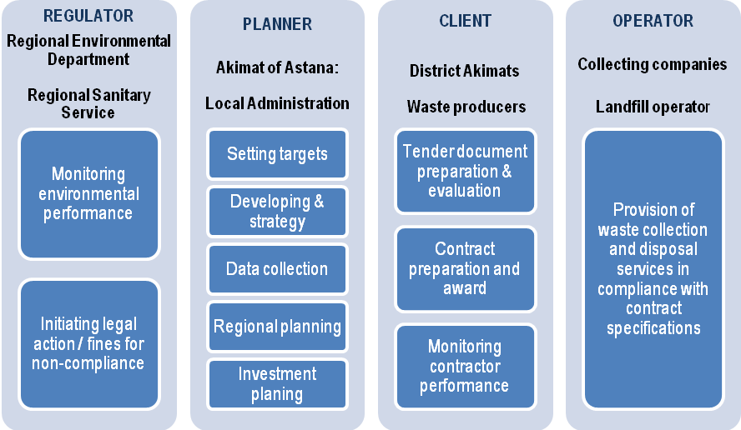

River Basin Management (RBM)
Policy Package

First Stage (PPM-1)

River Basin Management PPM-1 comprised 17 policy instruments (regulatory, economic, information based). Some examples:

Regulatory Instruments
- Legislation
- Surface water quality indicators
- Surface water quality standards
- Future budget allocations
- Water abstraction tariffs

Economic Instruments
- New system of fines introduced
- differentiated levels of tax/es to industries
- Methodology for an effective water tariff system

Information based Instruments
- Information available and disseminated
- Raising awareness of water users

Pilot project design

The Ili-Balkhash pilot project was undertaken over the 5-month period of March to July 2010. This pilot project focused on the conservation of Lake Balkhash.

Here are the main policy instruments and measures assessed in this pilot project:

- Environmental flow indicators – river flows, lake levels
- Management tools for ensuring adequate environmental flows
- Appropriate water tariff system for application to irrigated agriculture
- Identifying appropriate levels of water charges
- River basin management processes (including the identification of water bodies and reviews of the various users of water in the basin)

Second Stage (PPM-2)

Institutional reform and formation of a single body responsible for water regulation
Water management currently is fragmented and suffers from conflicts of interest. A unitary regulatory body is the advised approach - integrating the regulatory aspects of water use and wastewater disposal - and that such a body must have no (conflicting) economic interests in water use.

A new, five-class system of surface water classification with standards based on objective water use
The existing basis for setting surface water quality standards and limiting wastewater discharge concentration levels is widely regarded as unnecessarily rigid, often resulting in unachievable discharge limits.

Adopt the principle of minimum environmental flow as a key indicator at river basin level
The management of a river basin in a sustainable way requires a balance between a legitimate exploitation of the water resources and the maintenance of good environmental status.

Upgrade water monitoring networks and data processing
The systems for monitoring river flows and major surface abstractions need to be upgraded to meet the needs of effective river basin management and to assist transboundary water management.

Integrated management information system to aid strategic planning and decision making
Available information on water quality, quantity and wastewater is fragmented and incomplete. A unified system is required to assist strategic decisions affecting river systems at the basin level.

Ili-Balkhash Basin Pilot Project

Present Situation

Lake Balkhash is perceived to be under threat, principally through water demand in the trans-boundary Ili River catchment. The fear is that excessive water demand will cause water levels in the lake, and its surface area, to diminish, potentially causing serious disruption to the ecological condition of the lake and the Ili Delta and the economic activities dependent on them. There are two main water demand pressures: surface water abstraction from the upper Ili catchment in China and surface water abstraction in the Kazakh sub-basin, principally for irrigated agriculture. The consequences of potential climate change for the water inflow to Lake Balkhash are also of concern.

The technical condition of the much of the irrigation system overall is quite poor, water losses have been high and water metering is inadequate. Tariffs paid by water users in irrigated agriculture are very low and do not enable full recovery of O&M costs.

Lake levels

The chart opposite shows the record of observed water levels for Lake Balkhash over a 120-year period to date (blue). Also shown on the chart are the two control lines of 341 m above datum (red) and 342 m above datum (green): these have been acknowledged generally as critical and safe levels respectively for the Lake. After 1970 the water level in Balkhash started falling due to the infilling of the 28 km³ Kapchagai water reservoir and the growing evaporation losses.

Proposed Measures

The project prepared a plan for the conservation of Lake Balkhash. Key indicators and measures included:
- Lake Balkhash water level of at least 341 m to be maintained
- Key to this is that surface water abstractions from the Ili-Balkhash basin within Kazakhstan should be limited to a maximum of 3 km³ a year – subject to revision in periods of prolonged drought, climate change or if negotiations with China are inconclusive
- A review of existing agreement with China is needed and an agreement on consistent supply of water from China of not less than 12 km³ a year to the Ili-Balkhash basin needs to be negotiated
- Tariffs for irrigation water need to be increased up to 3 KZT/m³ to cover O&M costs
- In order to reduce significant water losses in the irrigation infrastructure, selective investment needs to be made to improve the water efficiency of irrigation systems.
- Current water use normatives need to be reviewed and reduced if necessary.
- Attention must be paid to the substantial reduction of the discharge of significant pollutants by industries.
- Construction of the Kerbulak counter-regulator for smoothing the releases from the upstream Kapchagai Reservoir.
- Creation of a unified and integrated database on the quantity and quality of water in the basin will further facilitate water management in the basin.
- Regular meetings of the Balkhash-Alakol Basin Council to take decisions and give recommendations.

Technical Outputs

All major technical outputs are available to view or download from the Ministry of Environmental Protection of the Republic of Kazakhstan. Reports are available on the policy packages developed in the project and the pilot projects. They include:

Result 2 Report (PPM-2) providing a basis for a three-year action plan for implementation and enforcement. Supporting reports are:
- first-stage policy package manual providing a more comprehensive, longer-term programme and the design of pilot projects
- comprehensive analysis of the existing system (2009) of policy instruments for environmental protection in the Republic of Kazakhstan

PPM-2 was developed as the culmination of sixteen months policy instruments analysis and evaluation, involving interactive, participatory workshops such as that held in Almaty in June 2009 – see opposite.

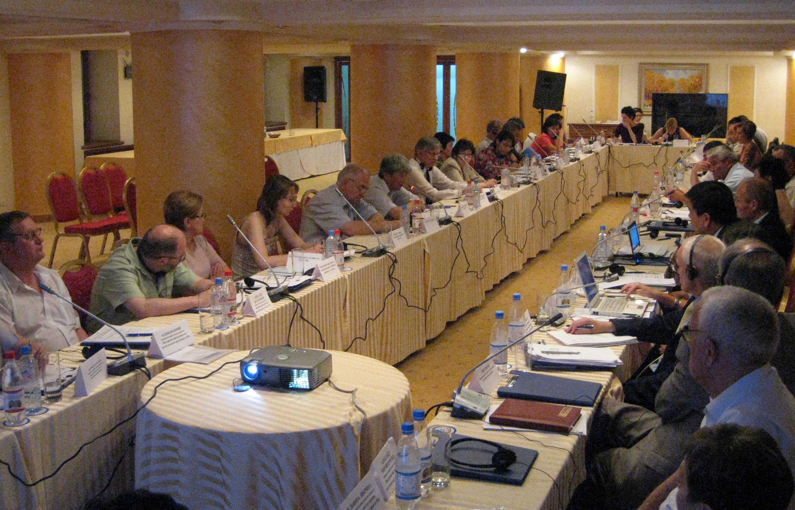

Well-attended, participatory workshops

Result 3 Report which provides the key findings and recommendations from the three pilot projects – one in each of the three selected key environmental areas for project action. Supporting reports in the three areas include the following pilot project reports:

River basin management
- Ili-Balkhash Local Environmental Action Plan – focusing on the quantitative aspects of water management with the objective of conserving Lake Balkhash and avoiding another Aral Sea disaster
- Eleven task reports on the Ili-Balkhash pilot project covering specific topics such as stakeholder consultation, fisheries, agriculture and irrigation water demand, irrigation tariffs, industrial water demand and municipal waste water treatment – see opposite

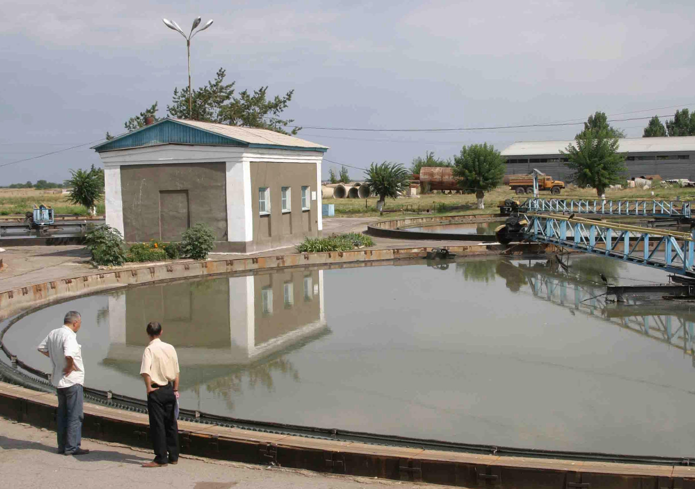

Primary sedimentation tanks at wastewater treatment plant serving Almaty City

Municipal solid wastes management
- Baseline review of Astana landfill site – covering design and operational aspects and the extent of provision for site closure and aftercare
- Guidance manual on good operational practices for landfill site management
- An assessment of the institutional structures regarding municipal waste management in Astana – covering waste collection and disposal operations (see opposite), contractual arrangements and the regulation of waste management facilities and practices. The report recommend simplifying the institutional framework and improving the contractual arrangements
- Guidance on setting waste management tariffs and an assessment of the existing tariffs against those needed for full-costs recovery. The report also evaluates the costs and needed tariffs for systems involving material recovery and recycling and makes a preliminary assessment of the public’s willingness to pay for these.

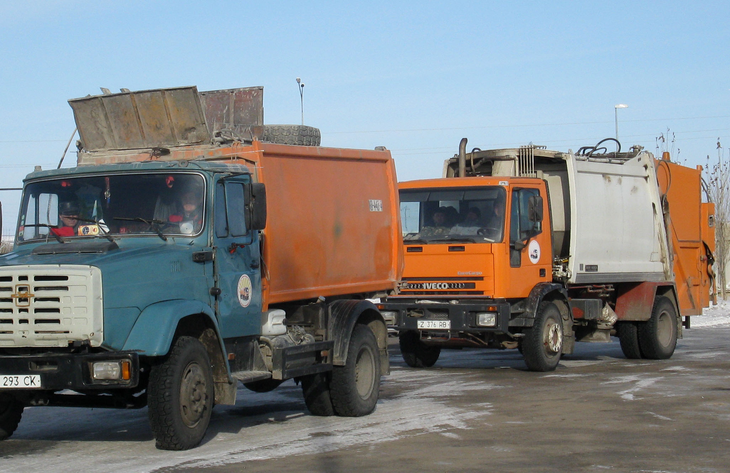

Waste collection trucks bringing municipal solid waste to the Astana landfill site

Air quality management
- An action plan for air quality improvement in Almaty – focused on transport issues. Key measures proposed include a strengthening of the institutional and operational capacity of the vehicle inspection system in Almaty. This builds on, in part, equipment specified by the project team and procured by the EU. Other measures include improvements to the air quality monitoring system, building on the observations of good practice in EU countries by officials on the international study – see opposite

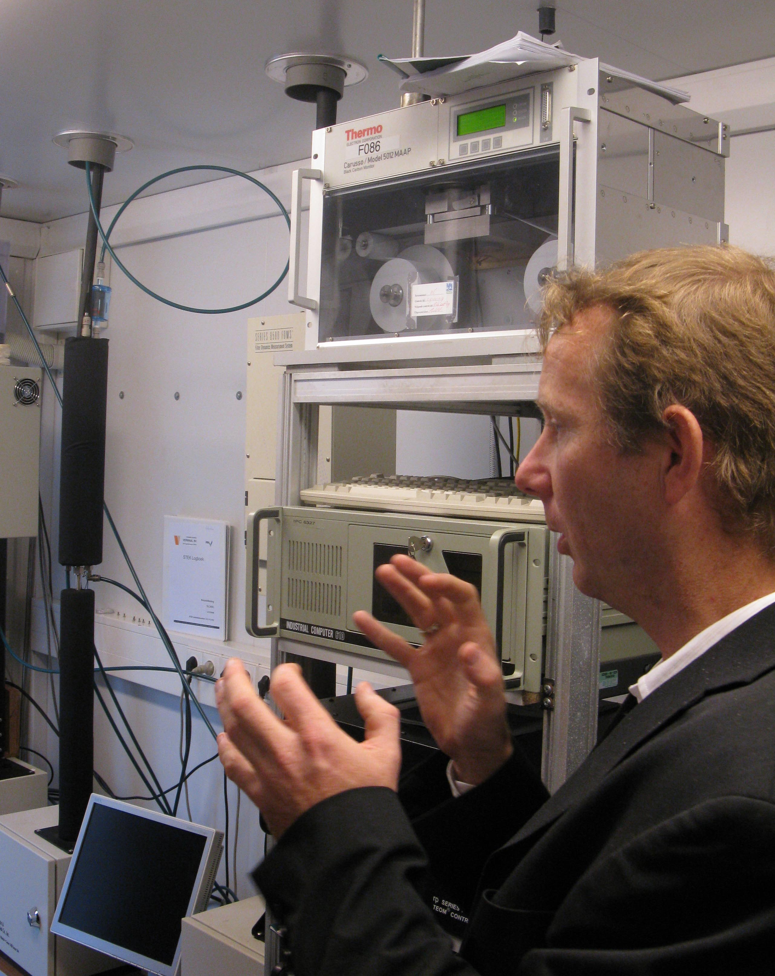

An expert explaining the workings of an automated air quality monitoring station in Rotterdam – Study Tour November 2009

Romana - Probably no need for the picture below – it doesn’t conform with the above
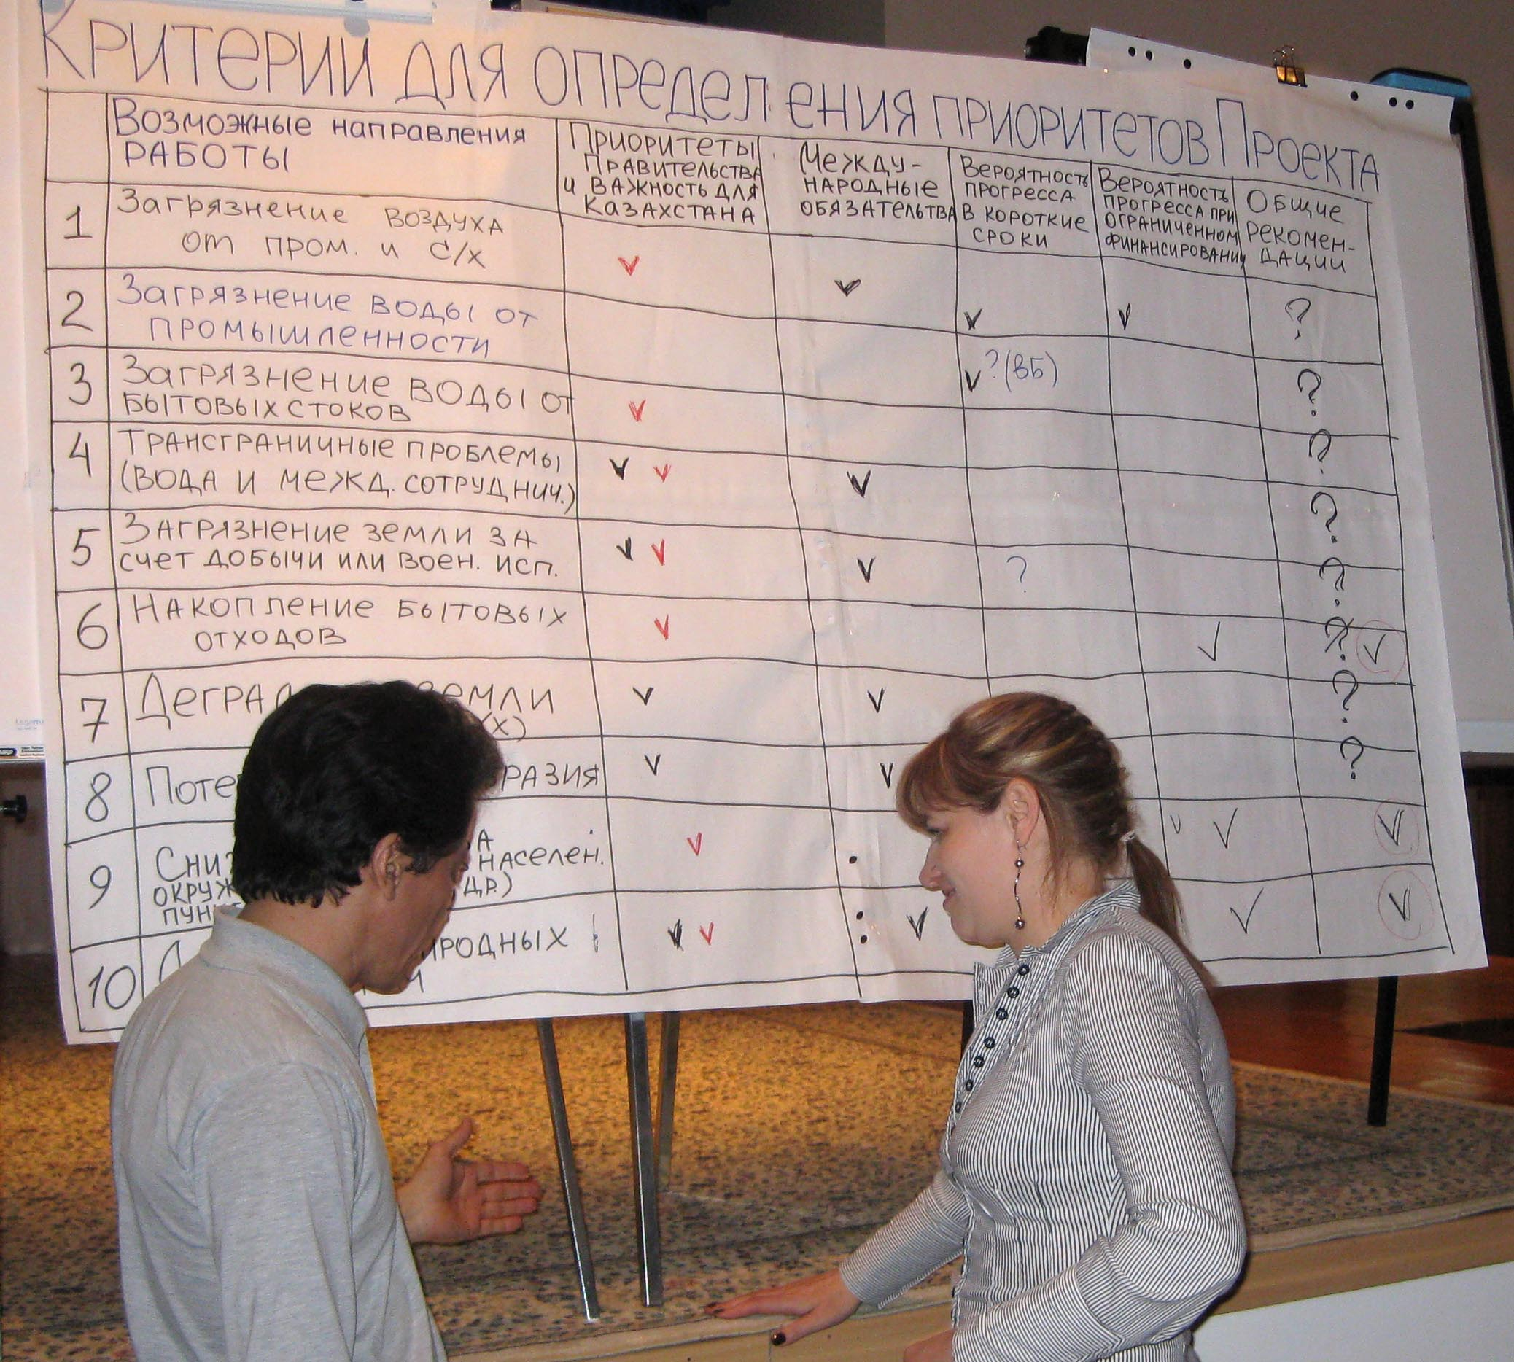

Reviewing criteria for the selection of key environmental areas for project action

